Name: Abdurrahman Qureshi

Roll no: 210451

EXPERIMENT NO 10

Q.) Program for Implemeting 3D SCALING

CODE:

#include <graphics.h>
#include <stdlib.h>
#include <stdio.h>
#include <conio.h>
int main(void)
{
int gdriver = DETECT, gmode, errorcode;
int midx, midy, i, sx, sy, sz;
initgraph(&gdriver, &gmode, "c:\tc\bgi");
errorcode = graphresult();
if (errorcode != grOk) /* an error occurred */
{
printf("Press any key to halt:");
getch();
exit(1); /* return with error code */
}
midx = getmaxx() / 2;
midy = getmaxy() / 2;
bar3d(midx - 50, midy - 50, midx + 50, midy + 50, 10, 1);
getch();
cleardevice();
printf("\nEnter sx,sy,sz:");
scanf("%d%d%d", &sx, &sy, &sz);
bar3d(midx - 50 * sx, middy-50 * sy, midx + 50 * sx, midy + 50 * sy, 10 * sx, 1);
getch();
closegraph();
return 0;
}

OUTPUT:
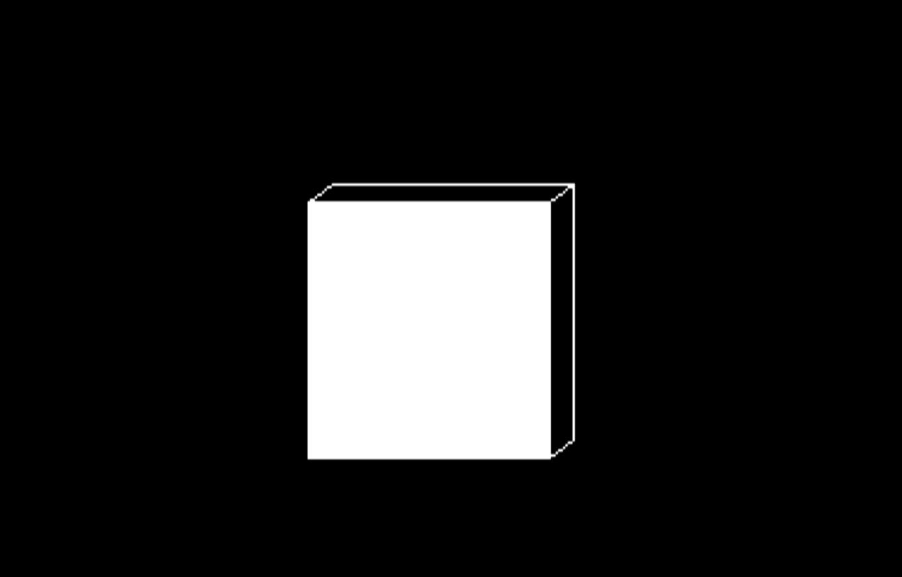

AFTER SCALING:
